**KST services include:   
    http://www.ksthawaii.com/dotblue.gif** Telecommunications Service Support  
    http://www.ksthawaii.com/dotblue.gif Assessment of communications and networking needs  
    http://www.ksthawaii.com/dotblue.gif Installation of structured voice and data cable networks (Inside Plant)  
        http://www.ksthawaii.com/dotblue.gif System development, integration, and deployment services  
    http://www.ksthawaii.com/dotblue.gif IT professionals for information operations and maintenance  
    http://www.ksthawaii.com/dotblue.gif Multimedia Visual Information services  
    http://www.ksthawaii.com/dotblue.gif Program/Project Management Support  
    http://www.ksthawaii.com/dotblue.gif Help desk support  
    http://www.ksthawaii.com/dotblue.gif Fully integrated CCTV-based security solution and installation  
    http://www.ksthawaii.com/dotblue.gif Information Assurance and Cyber Security Administration  
    http://www.ksthawaii.com/dotblue.gif Planning and design of office workstation topology  
    http://www.ksthawaii.com/dotblue.gif Outsourcing/staff augmentation  
    http://www.ksthawaii.com/dotblue.gif Management consulting and organizational development

**Your Technology Solution**

**Providing IT Services Around the Globe**

***www.ksthawaii.com***



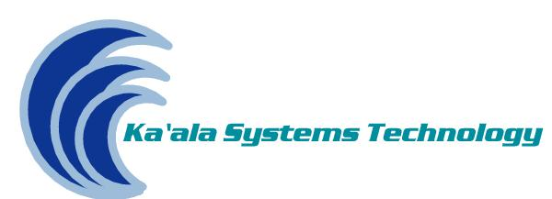

***KST*  
Native Hawaiian Owned**

|  |
| --- |
| **About Us** |

|  |  |
| --- | --- |
|  | Ka’ala System Technology Corporation (KST) is an emerging, growing, high technology company specializing in information and communications systems including both Local and Wide Area general operations support services, Telecommunication support services, CCTV/VTC and Multimedia & Audio Visual support services. |

**Contact Us**

Ka’ala Systems Technology

98-025 Hekaha Street

Bldg. 2, Suite 224A

Aiea, HI 96701

Office: 808.521.7000

Fax: 808-521-7003

KST@ksthawaii.com



**NAICS Codes**

541519 – *(Primary)* Other Computer Related Services

541512 – Computer Systems Design Services

541513 – Computer Facilities Management Services

541611 – Administrative Management and General Management Services

KST has additional NAICS Codes which may be viewed by visiting our website at [www.ksthawaii.com](http://www.ksthawaii.com)

**Core Competencies/Specializations**

Information Technology (IT) support, system development and integration, Telecommunications support, network system configuration/design support and technical assistance; network security, CCTV-based security solution, audio /visual support and secure/non-secure VTC systems solutions. KST also provides data processing, hosting, and related services; program/project management, administrative support services, computer equipment sourcing, maintenance and upgrade; installation of ISP structured voice and data cable networks.

**Small Business Certification**

SBA 8(a)-certified, Entrance Date: 11/26/2013, Exit Date: 11/26/21; Service Disabled Veteran Owned Small Business, Small Disadvantage Business (SDB); Department of Transportation (Hawaii) Disadvantage Business Enterprise (DBE); Native Hawaiian Owned, Minority-Owned

GSA Schedule 70; GS-35F-196BA

GSA 8(a) STARS II: GS00Q17GWD2199

SeaPort-e Prime Contractor



## **Business Description**

Ka’ala System Technology Corporation (KST) is an emerging, growing, high technology company specializing in information technology systems, communications systems: Local and Wide Area general operations support services and Telecommunication support services. Our corporate objective is to establish a firm built upon: 1) a diverse, nation-wide clientele; 2) an excellent reputation for performing on time, within budget to complete customer satisfaction; 3) cost competitiveness; 4) consistent profitability; and 5) a commitment to employee growth and development.

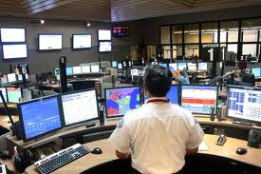

## **Key Clients**

* Defense Logistics Agency – Pacific Region, Hawaii, Japan, Okinawa, S. Korea, Singapore, Alaska, and Guam
* NAVSUP Fleet Logistics Center, Joint Base Pearl Harbor Hickam (JBPHH), HI
* Emergency Management Dispatch Support Services, JBPHH, HI
* U.S. Army Garrison-Hawaii Command, Fort Shafter, HI
* 747th Communications Squadron, US Air Force, Pacific Air Forces, HI
* 30th Naval Construction Regiment, Camp Covington, Guam
* Command Task Force 75, Navy Expeditionary Forces Command Pacific, Camp Covington, Guam
* US Army Corp of Engineers, Ft. Shafter, HI
* Naval Expeditionary Combat Command Pacific, JBPHH, HI; Port Hueneme, CA; Gulfport, MS
* Pacific Missile Range Facility, Kauai, HI
* 47th Communications Squadron, Laughlin AFB, TX
* 49th Communications Squadron, Holloman AFB, NM